# iOG Solutions Profile

iOG Solutions stands for intelligent O&G solutions. iOG Solutions is an Independent and reputed provider of consulting and implementation services for advanced and Intelligent Software solutions in the Oil & Gas industry. It was founded in 2013 and is based out of Pune, India and Abu Dubai, U.A.E.

* Our team of consultants has strong domain knowledge in upstream and downstream O & G industry and all leading software solutions.
* Skilled, motivated & self-driven iOG consultants with Strong O&G domain knowledge
* Extensive experience in delivering advanced software solutions
* Executed 15+ projects in the last two years in Europe, the Middle East, India, and SE Asia
* Intellectual team of consultants converting refinery challenges into enriched experience & skills
* iOG focuses on process-centric software solutions and provide independent application and expert consulting services:
* Implementation Services on
  + Process Simulation
  + Manufacturing Execution System
  + Operator Training Simulator
  + Advanced Process Control
  + Planning & Scheduling
  + Energy Management
  + Modelling & Optimization
  + Supply & Distribution
  + Trading & Risk Management
  + HSE & LIMS
* Training
* Support Services
* Advanced Solutions – Master IT plans
* Business Process Maps
* Functional requirements
* Business Cases for Process Improvement
* Product and Implementation RFQ
* Technology comparison and evaluation
* Project Management Services
* Consulting on Industry Best Practices
* Technical / Process trouble-shooting
* Third-party Audit of Process / Projects
* Subject-matter Expert (SME services)

Strategic IT plans

Planning & Scheduling

Consulting Services

APC

OTS

MES

Training Services

ETRM

Modeling & Optimization

Independent Application Services

Consulting Services

* Resulted in oriented working philosophy with a focus on decisions and practical actions tailored to suit our clients’ unique requirement
* Strong capabilities to sustain success by engaging and building momentum at various levels of the organization’s functional architecture

# iOG Solutions for Downstream Oil and Gas Industry

Oil & Gas downstream includes procurement and supply of Crude oil, refining operations, product blending, storage and distribution of finished products. The midstream operations such as trading, risk management, supply & distribution are also included in downstream verticals at iOG. In addition, it includes Petrochemicals and LNG facilities. This will be elaborated and segregated as separate areas in the future.

iOG services advise all the areas shown in the simplified diagram below:

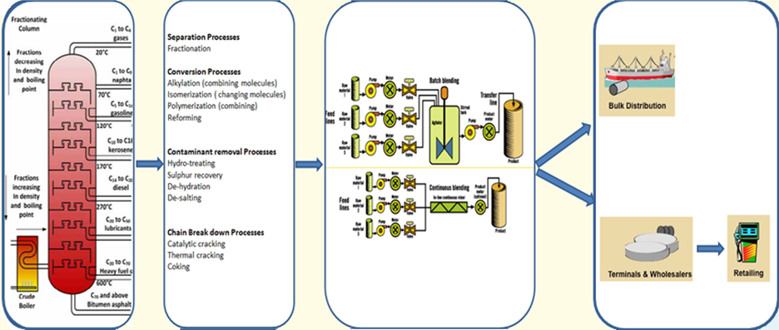

Crude Oil Fractionation

Bottom of the barrel

upgradation

Product Blending

and Storage

Product Distribution to potential Markets

iOG Solutions provides best in class expertise, solution and work flow for all the disciplines throughout the Mid-stream and Downstream Life cycle. We understand customer’s requirement and provide suitable solutions including software, consulting services, and methodology to address these requirements. Our experts in Oil & Gas Downstream work in tandem with the client team to give cost effective solutions and hence improved profitability for our customers.

Following is the functional view of downstream industry and list of our major service offerings in this vertical:

* **Supply Chain Management**
* Energy Trading and Risk Management and Pricing tool application
* **Manufacturing Execution Systems**
* Advanced Process Control & Base Control Loop Tuning
* **Simulation & Modeling**
* Energy Management

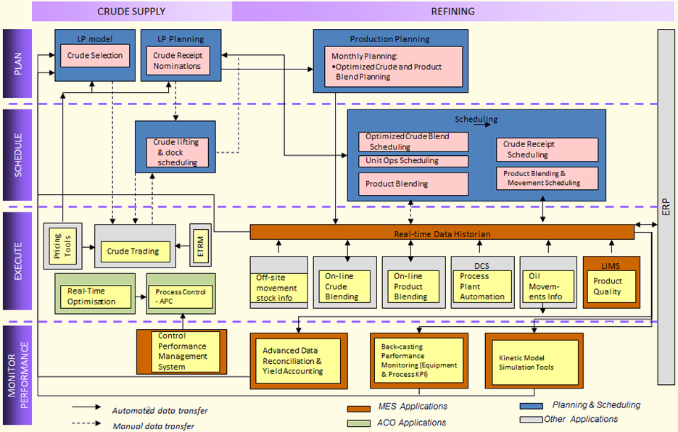

# iOG Solutions for Supply Chain Management:

iOG understands the diversity and complexity of refinery supply chain operations. We help maximize profitabilty through the following services at various levels through a “best practice” and “best fit” approach using our enriched knowledge and experience in leading software solutions:

1. Production Planning :
   * Build LP models from scratch or update existing models through the usage of leading software solutions
   * Implement Planning business process – Short term & long term planning
   * Develop business processes for crude and product evaluation
   * Perform LP configuration studies
   * Investigate potential areas for Profit improvement
   * Provide end-to-end integration
2. Refinery Scheduling
   * Build scheduling models from scratch or update existing models through the usage of leading software solutions
   * Implement business process which involves Dock, feedstock, process unit scheduling, product blending, and distribution
   * Develop case scenarios for process unit turn-around shutdown planning and to study the impact of throughput variations
   * Customized report generation as a guideline to Refinery Operations management group
   * Integration of scheduling tool with data historian, Lab information and tank guaging systems
3. Back-casting / Retro-Analysis
   * Implement Retro-Analysis business process through the design of functional scope and high-level architecture
   * Incorporation/updation of yield shift vectors in the LP model through simulation and scheduling inputs
   * Recommend corrective actions post identification of gaps in the field operation as well as in the LP architecture
4. Profit improvement studies
   * Usage of simulation and LP tools in tandem to identify potential areas for margin improvement such as product maximization, Shut-down Vs Catalyst life, alternate product routings, etc.
   * Develop stand-alone models for tracking refinery profitability on a regular basis
5. LP Configuration studies
   * Perform “What-if “ analysis to recommend the right unit configuration and technology to meet the desired product specifications through multiple LP and simulation runs

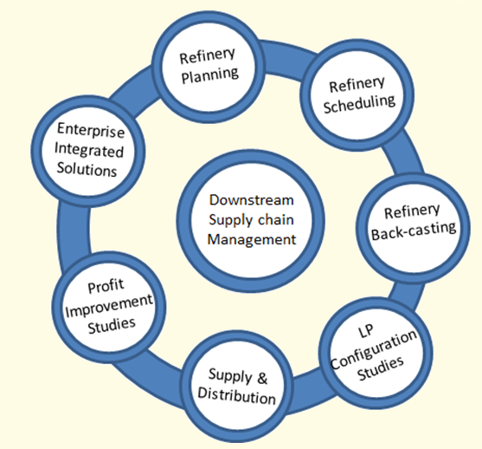

1. Supply and distribution
   * Provide end-to-end retail automation solutions from Forecourt to HQ
   * Optimization of Supply & distribution at depots
   * Demand Management – demand forecasting, analytics, and colloboration for better demand management
   * Supply Chain Operations & Scheduling
2. SC Integration: Develop and implement Integrated Supply Chain Enterprise solutions for the Oil and Gas Downstream sector conglomerating all the business processes across the value chain into one single module for better visibility, ease of data exchange and high level monitoring.

# iOG Solutions for Energy Trading and Risk Management & Pricing Tools:

iOG Solutions with its vast experience in the area of ETRM can help our clients choose the right ETRM solution that fits-into the business needs at the optimum implementation cost & duration. Our in-depth knowledge on the deliverables from leading pricing tool applications will help us in recommending the apt tool that completely satisfies the business needs of our clients.

Our Services in the ETRM area are as below:

* Capture AS-IS and Define future TO-BE for trading.
* Recommend solutions which offer quicker payback and lesser disruption to services
* Defined deal capture, pricing workbench, marine scheduling
* Mark To Market (MTM), inventory projection for international crude (Onshore, In-Transit, Sumed, etc.)
* Define deal types (spot, term, EFP), external feeds (ICE, NYMEX, Platts, Opis, and Argus data)
* Three way Pegging, Transportation, Trades (affiliate and third-party, statistical, buy/sell, OTC/PTP, swap/EFS, futures, internal)
* Commodities (Crude, Products, Gas, LCCT, Lubes), ROME, Ticketing US Equity, including P/L Credit Report
* Effective Straight Through Process (STP) from Front ~ Middle ~ Back Office
* Implementation of new trading scenarios for Crude, Gas, Financial and LNG.
* Credit, Risk and Counterparties management and reports.

Our Services in the Pricing Tool application are as below:

* Study the viability of the existing pricing tools, if any
* Design business processes and functional architecture to ensure the right flow of market information throughout the organization
* Design and implement the integration of pricing tools with critical applications in the refinery business process such as Production Accounting and Production planning applications

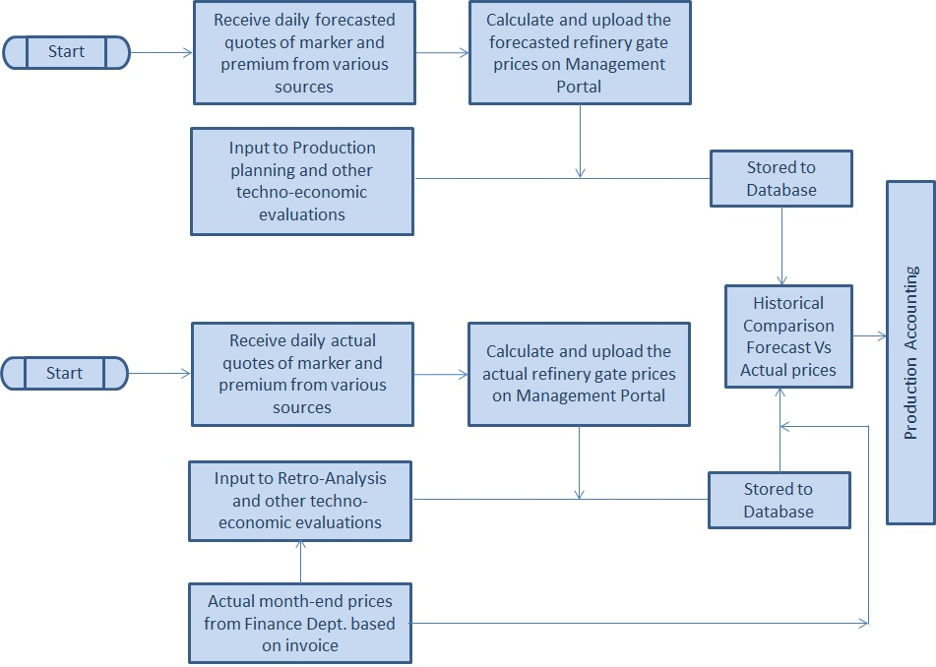

# iOG Solutions for Manufacturing Execution systems:

We at iOG have strong domain knowledge and can provide support, consultation and implementation advanced solutions in the area of Production Accounting.

Below are our offerings in this area:

* + Provide automated seamless data import processes such as Integration of Data Historian, OMS, etc. with Production accounting tool and design well-defined quality control steps to ensure import of right data.
  + Implementation and support of production accounting tool
  + Deploy expert solutions to track and mitigate gross errors in complicated networks
  + Provide solutions for auditing the oil accounting system and develop procedures to aid transparency, repeatability and gain refinery-wide acceptance
  + Design and establish “best-practice” standardized and customized reports
  + Tuning and maintenance of oil accounting systems to reduce daily and monthly imbalances to tolerant levels
  + Design, sensitivity analysis and integration of KPI’s with other applications
  + Consulting services to study the oil accounting system “As-is” and provide best-in class solutions to improve instrumentation reliability and network infrastructure robustness

iOG helps customers to give solution to Production accounting tool as shown below:

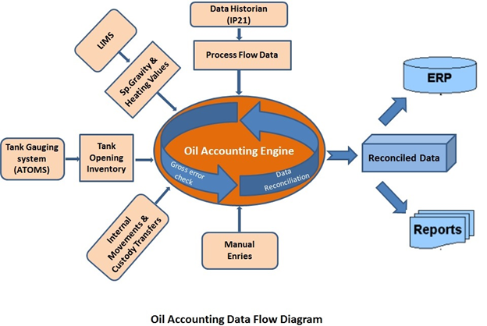

# iOG Solutions for Advance Process Control & Base Control loop tuning:

iOG Solutions provide customers with the experience needed to address plant design, regulatory control, identification of profit improvement, commissioning, training, and post-audit assessments. We have strong expertise in serving our clients in the tuning of control loops for improved performance. This experience is derived from working on the best technology in the industry.

Our Services in the APC area are as below:

* Evaluation of current plant operations and existing automation performance
* Benefits analysis to define and quantify the expected economic improvements
* Development of a Functional Design Specification for project implementation, which details APC applications, control strategies, functionality to be provided, and how benefits are to be achieved
* Recommendation for additions, modifications, and upgrades of instrumentation, analyzers, or systems necessary to support effective application of APC technologies
* Estimation of budgetary project costs (±30%)
* Analysis of financial return on investment for project justification and prioritization
* Information gathering - review a list of base plant and process data for preliminary analysis prior to onsite work
* Current automation status review– An audit of existing automation systems and instrumentation to baseline status and performance will be conducted.
* Opportunity analysis – An investigation to determine the potential improvements from APC and estimate expected economic gains will be performed.
* Offsite analysis and report generation - A detailed report to document results, analyses, functional design specifications, project plans, and recommendations will be generated.
* Report transmittal and follow up – A final report will be delivered and follow-up meeting scheduled to review and discuss the report.
* APC implementation – Project execution or support services to implement recommended or specified advanced process control applications (depending on scope)



Our Services in the area of Control Loop tuning are as below:

* Identify top 10 control loops for economic improvement
* Build real time performance dashboards
* Build KPIs to enhance plant performance
* Identify interacting/oscillating loops
* Implementation of control loop tuning software
* Integration with existing assets
* Assessments of Overall Sensor Health, Valve Health, and Controller Health
* Built different datasets to identify process models
* Control loop readiness for APC implementation
* Develop enhanced tools for root cause problem solving
* Advanced regulatory control studies, suggestions and design

# iOG Solutions for Simulation & Modeling:

iOG simulation and modelling services have evolved through vast experience in developing new and improved models for the calculation of properties, flow assurance studies and various start-up and shut-down studies. We have strong capabilities in both Steady state and Dynamic simulation to perform Mass and Energy balance, prediction and control of real processes in real time.

Our Services in this area are as below:

1. Steady state and Dynamic simulation
   * The building of dynamic/steady state simulation models.
   * Engineering studies and report generation.
   * Modification/maintenance of dynamic/steady state simulation models.
   * Collaborating on study projects with EPC’s.
   * Development of user defined modules on various platforms for proprietary calculations.
   * Pinch analysis
   * Simulation model tuning
   * Pipeline modeling
   * Hydraulic studies
   * Safety studies including Safety network analysis



1. Rigorous Kinetic reactor modelling and LP Yield shift vector generation
   * Build unit kinetic reactor models using rigorous simulation
   * Model Calibration and validation
   * Model validation using actual plant data
   * Precise data generation for LP tool through case scenarios and statistical analysis
   * Build customized LP utility templates to pass on base and delta yield vector data from simulation tool to LP models
   * Data validation and reconciliation to ensure data completeness
   * Optimization of refinery-wide performance using integrated models

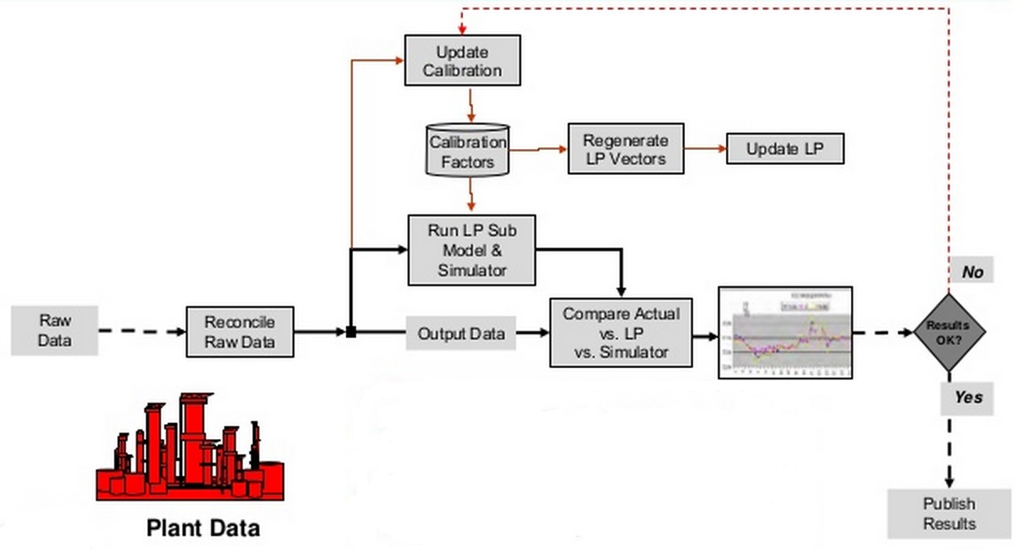

# iOG Solutions for Energy Mangement Services:

iOG Solutions for Energy management include analysis of energy usage through statistical models, resolve energy imbalances, identify equipment-specific operational cost improvements and performance monitoring.

Our Services in this area are as below:

* Conducting energy optimization studies to boost profitability
* Identify potential areas of energy recovery
* Devise comprehensive steam and fuel models for analyzing utility systems and predict results for a wide range of operating conditions
* Devise energy performance KPI’s to track the actual performance
* Develop optimized operating strategies during non-routine and challenging situations

# Our Solutions

# iOGImplement

Experts in the different technology across the Oil & Gas industries in our team can help you with the implementation of these technologies. We specialize in all the technologies for the following areas and have experience in most leading industry software solutions:

* Refinery Planning & Scheduling
* Backcasting /Retro-Analysis
* Supply and Distribution
* Manufacturing execution systems (MES)
* Advanced Process Control
* Dynamic and Steady-state Simulation
* Rigorous reactor modelling
* Model tuning
* LP yield-shift vector generation

# iOGConsult

At iOG, we believe in creating an intelligent environment, where we continuously learn & update ourselves with latest technologies & best practices in the world. We provide consulting services to improve our client’s process & bringing them up to best practices in the industry.

We renovate our client’s business using the following business tools

* Business Process Mapping (As-Is, To-Be and Gap Analysis)
* Downstream Supply Chain Optimization Consulting Services
* PMC services
* Data Management methodology and application integration review
* Establishing industry-wide best practices

# iOGStudy

At iOG we undertake studies using the latest technologies, tools & best practices for identification and quantification of profit improvement ideas in the following areas:

* Profit improvement studies
* LP Configuration Studies
* Energy Management
* Steam Network optimization
* Base control Loop Tuning
* Hydrogen management
* Pinch Analysis
* Energy Trading and Risk Management
* Pricing tool application

# iOGTrain

Experts in our team dealing with technology areas across Oil & Gas industries can help you with training on these technologies at our office or at your site. We specialize in the following technologies and offer standard & custom training programs for most leading industry software solutions:

* Refinery Planning & Scheduling
* Supply and Distribution
* Manufacturing execution systems (MES)
* Dynamic and Steady-state Simulation
* Rigorous reactor modelling
* Advanced Process Control